Freeing the Body in Water
Explore Integral Aquatic Therapy
with
Sol Petersen (New Zealand) and Bibiana Badenes (Spain)
Introductory Class July 7,8,9, 2011
in beautiful Benicassim, Spain [near Castellon, one hour from Valencia]
Treat Yourself …..Come join us for a 3-day experience on the gorgeous Costa Azahar in Spain. Our venue is just a few minutes walk from the beach and the salt water pool for our workshop is heavenly. Enjoy this for yourself and also learn how to share this nourishing treatment with others.

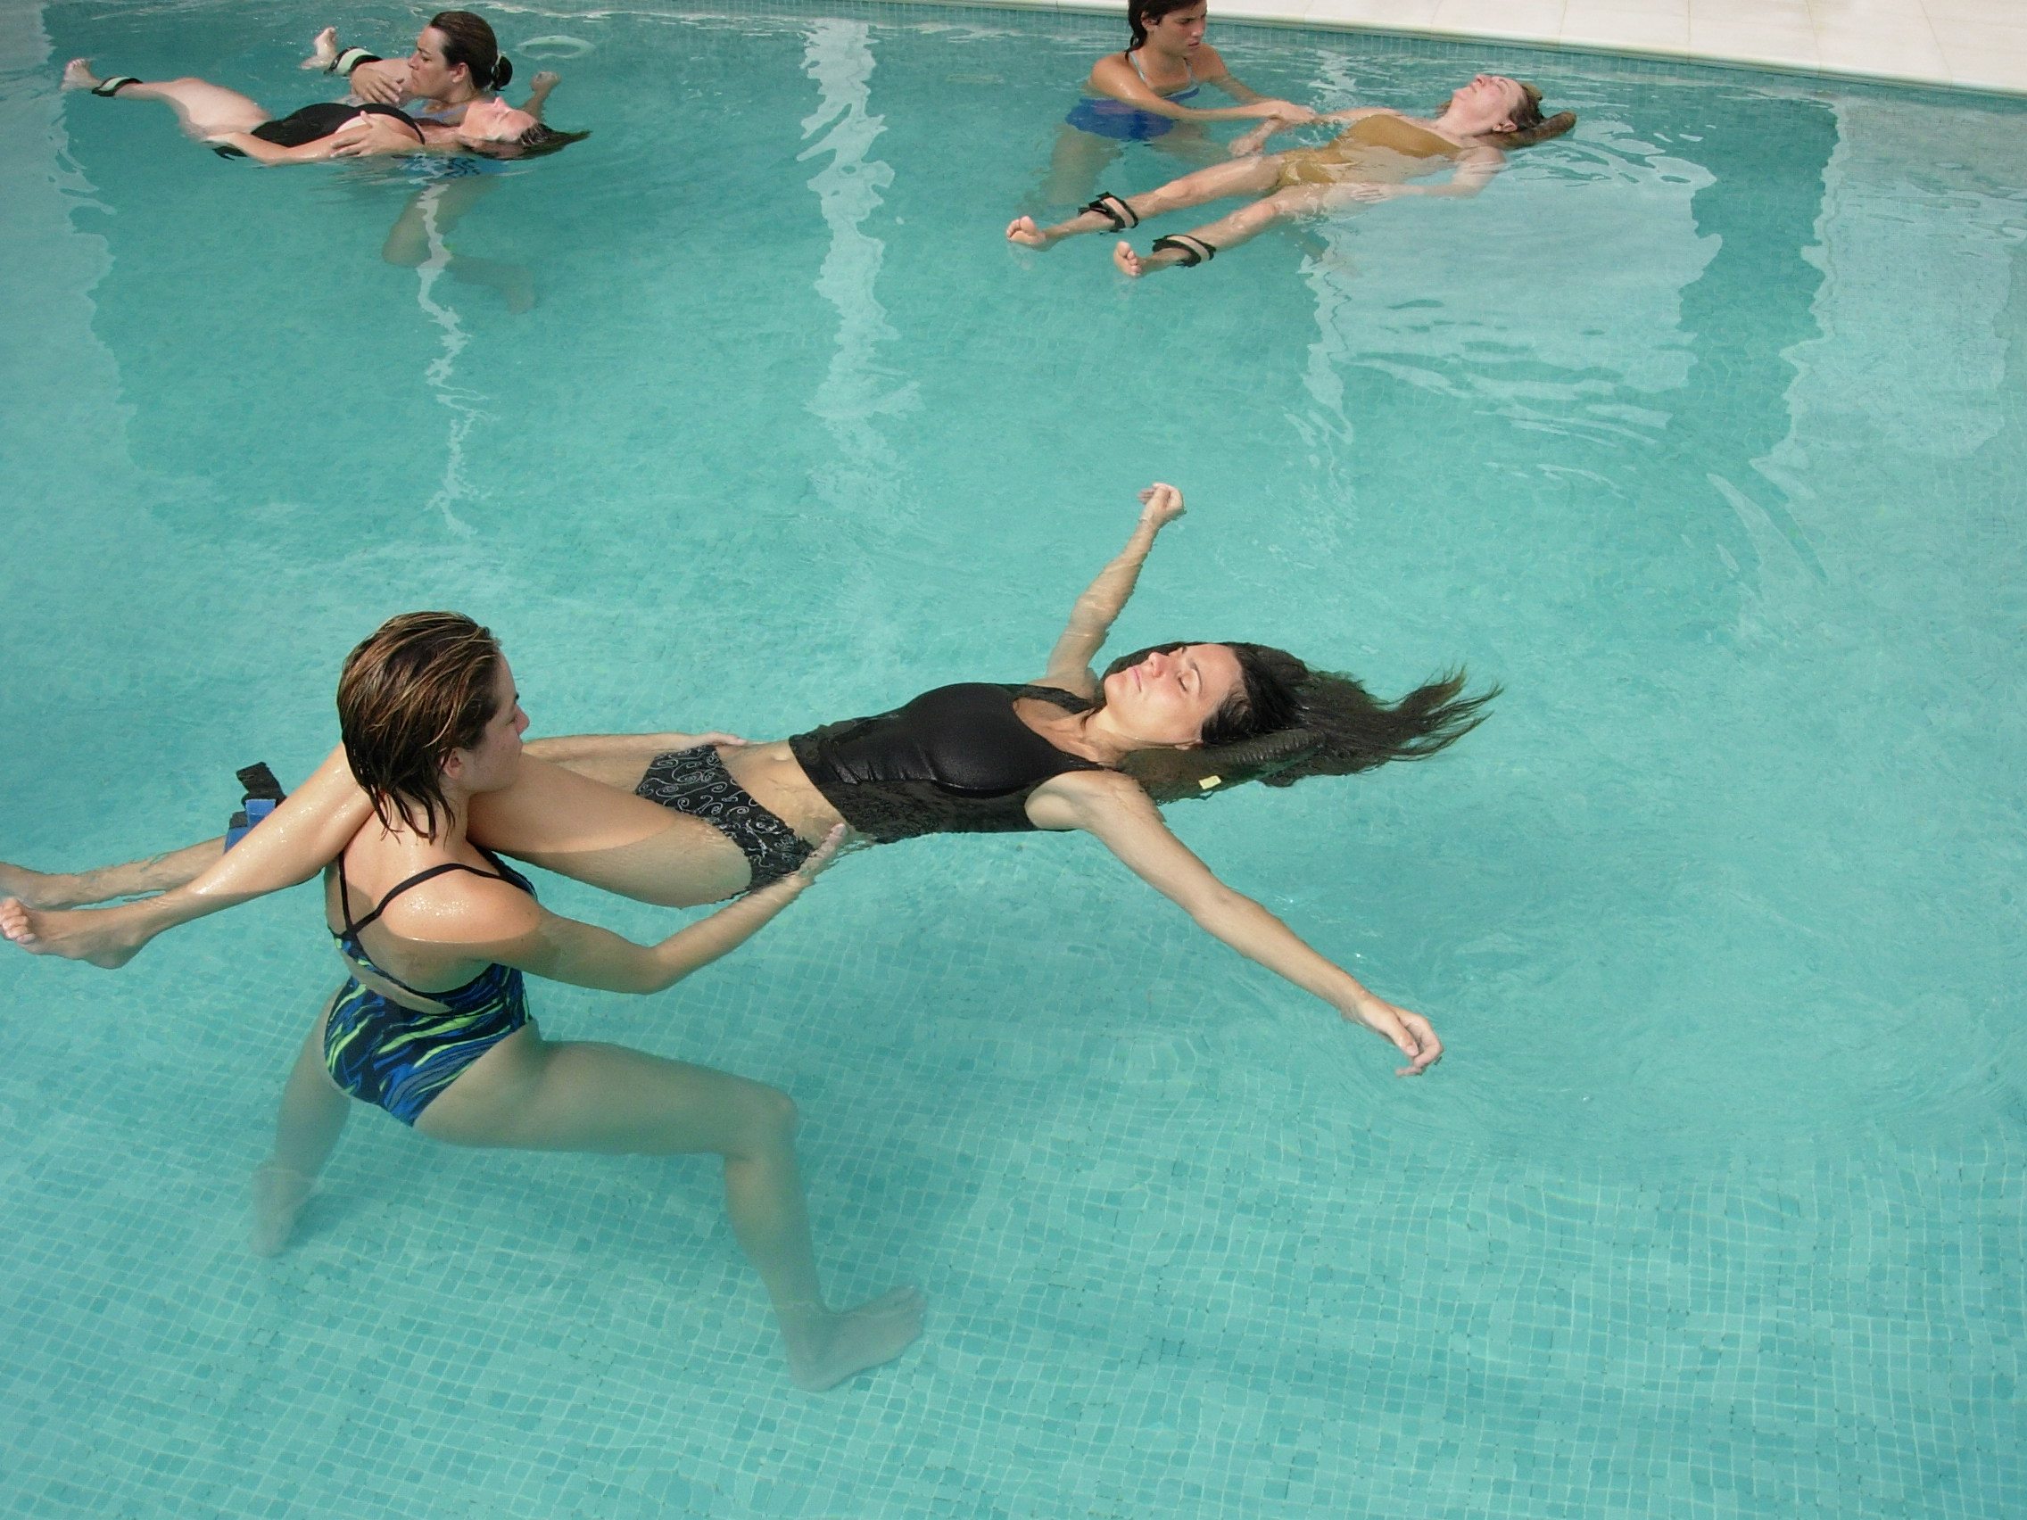
What is Integral Aquatic Therapy Integral Aquatic Therapy is a gentle and effective form of body therapy and rehabilitation performed in warm water (35 degrees C.). It combines elements of soft tissue manipulation and massage, joint mobilization, trigger point therapy, stretching and positional release all woven seamlessly into a beautiful sequence of fluid movements. In an aquatic session the client can totally relax. The face and nose remain out of the water as they are supported by the water, the healing hands of the practitioner and aquatic floats if necessary. Integral Aquatic Therapy (Terapia Integral Acuatica or TIA in Spain) was developed by Structural Integration trainer, psychotherapist, Tai Ji teacher and longtime Watsu practitioner, Sol Petersen and Bibian Badenes, a Rolfer and physiotherapist with hydrotherapy experience. They have evolved their holistic method of aquatic therapy integrating diverse therapeutic influences.

Who would benefit from this workshop?
Massage therapists and bodyworkers, aquatic specialists, occupational and physiotherapists, and anyone who delights in the flowing beauty of the body in water. It will be of particular interest to those involved in the healing arts and anyone who wants to be part of an exciting new modality of aquatic bodywork

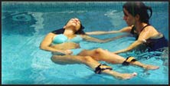

The Body Moves Freely in Water
The curative effects of the warm water produce spontaneous responses in the connective tissues and the autonomic nervous system as well as on the emotional and energetic levels. This leads to a state of deep relaxation and stress release. In this state, the freeing of myofascial restrictions and joint adhesions facilitates greater range of motion and the opening of new neuromuscular pathways.
Unlike bodywork in the field of gravity where the client’s body is stabilized by the treatment table, in the water, the body is free to move and be moved and stretched both locally and globally in unusual ways and directions. The entire spinal column can be mobilized in snake-like undulations and spirals, impossible to achieve outside the water. The hip and shoulder joints can be more easily decompressed and guided into new movement pathways in a pain-less environment. The hydrostatic pressure of the water is like hundreds of gentle hands holding and massaging the whole body from every direction simultaneously.

Returning to the Source – Our Very Nature is Water

The first aquatic session is often a surprising and profound experience touching deep sensory and even emotional levels. The sense of total support, trust and body fluidity and freedom is unique and astonishing. We may feel like a piece of seaweed being danced by the sea goddess, lose all sense of our habitual body identification as if we had become part of everything, feel like we have returned to the womb or simply that we have fallen into the deepest relaxation of our life.
For a patient suffering rheumatoid arthritis (RA), osteoarthritis (OA) or chronic pain (CP) or any movement disability, this gentle therapy may be an introduction to a feeling of joy or freedom in movement. For most of us, the last time we spent an hour floating in warm water was pre-birth - swimming in our mother’s tummy, listening to the echoic rhythms of her heartbeat. As we are essentially mostly water (over 80%), it is like a primal return to onerself. The unconditional support and safety may also assist in the resolution of traumatic and psychosomatic conditions on both the physical and emotional levels.

The programme:
Paticipants will experience a unique approach to aquatic bodywork and learn how to hold and move a partner through basic positions. You will learn what you need to know about working in the water, starting and completing a session and basic techniques from Integral Aquatic Therapy. You will learn about touch in and out of the water. You will also learn about your own body mechanics - how to support and move a person as effortlessly as possible in the water and how to stay centred in your own body. You will give the work; receive it from a partner and from the teachers so you experience it in your own body. And most of all you will have a wonderful time and deeply relaxing experience in a beautiful place only minutes from the Mediterranean Sea.

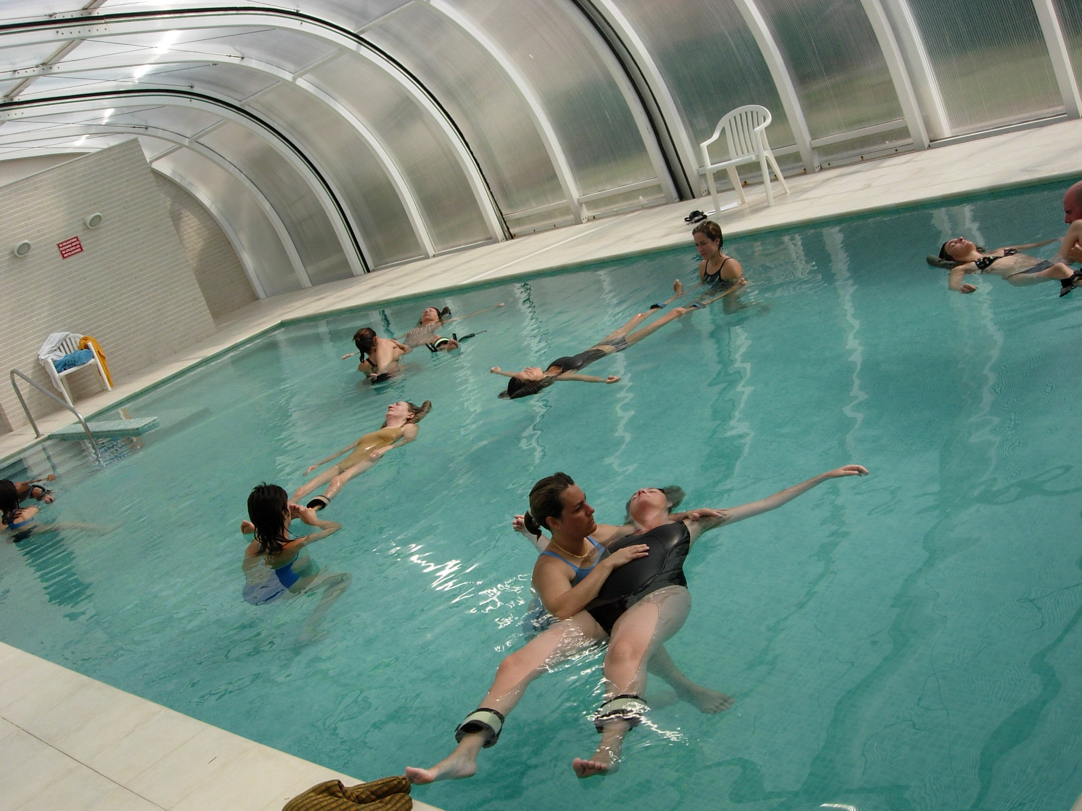
Tuition - 290 Euros Classes – Thursday July 7, 9am-8pm, July 8, 9am-5pm, July 9, 9am-5pm
Accommodation: cost for full board is 60 to 80 Euros per day, contact Bibiana for hotel links
To register or for more information contact – Bibiana Badenes, Centro Kinesis Physiotherapy Centre, Benicassim, Spain Tel 0034 96430275, kinesis@kinesis.es, or Sol Petersen, sol@theradiantbody.com, tel 006478668971 or mob 0034672878499
Sol Petersen is an Integral Aquatic Therapy trainer, certified Watsu practitioner, Adaptive Physical Education teacher, a Structural Integration trainer, Aston Movement Coach, Cranio-Sacral therapist, Tai Ji teacher and is also trained in Hakomi Experiential Psychotherapy. He has been practicing Aquatic Bodywork for over 20 years and loves to share this powerful and effective form of therapy. Sol lives in New Zealand and teaches internationally.
Bibiana Badenes is an advanced Rolfing practitioner, Rolfing Movement teacher and a physiotherapist who has always explored the cutting edge of the potential in physical therapies. She is trained in traditional hydrotherapy and with Sol is the co-founder of Integral Aquatic Therapy (TIA or Terapia Integral Acuatica) and has developed a unique holistic programme for treating patients with rheumatoid arthritis and those dealing with stress and burnout. She teaches Integral Aquatic Therapy to therapists in Benicassim and other parts of Spain.



